#Assignment No.2 : Decision Tree Classifier
#Import packages
Import numpy as np
Import pandas as pd
#reading dataset
dataset=pd.read_csv(“c://data.csv”)
x=dataset.iloc[:,:-1].values
y=dataset.iloc[:,5].values
#perform label encoding
from sklearn.preprocessing import LabelEncoder
LabelEncoder _X= LabelEncoder ()
X=X.apply(LabelEncoder().fit_transform)
print X
from sklearn.tree import DecisionTreeClassifier
regressor=DecisionTreeClassifier()
regressor.fit(X.iloc[:,1:5],y)
#predict value for the given expression
X_in=np.array([1,1,0,0])
y_pred=regressor.predict([X_in])
print “Prediction:”,y_pred
from sklearn.externals.six import StringIO
from IPython.disply import Image
from sklearn.tree import export_graphviz
import pydotplus
dot_data = StringIO()
export_graphviz(regressor, out_file=dot_data, filled=True, rounded=True, special_characters=True)
graph=pydotplus.graph_from_dot_data(dot_data.getvalue())
graph.write_png(‘tree.png’)
data.csv
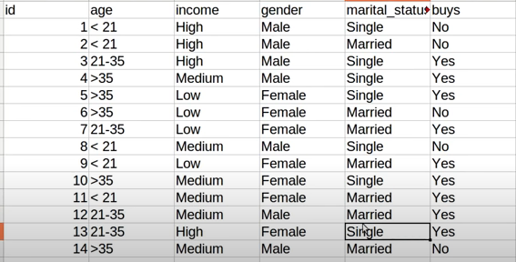
Output :
